ZONAL COMPETITIONS - SPORTS

DAV Pushpanjali secured Second place in Zonal Badminton tournament.
Ayush, Vaasvi and Ayushi selected for Badminton Interzonal team.
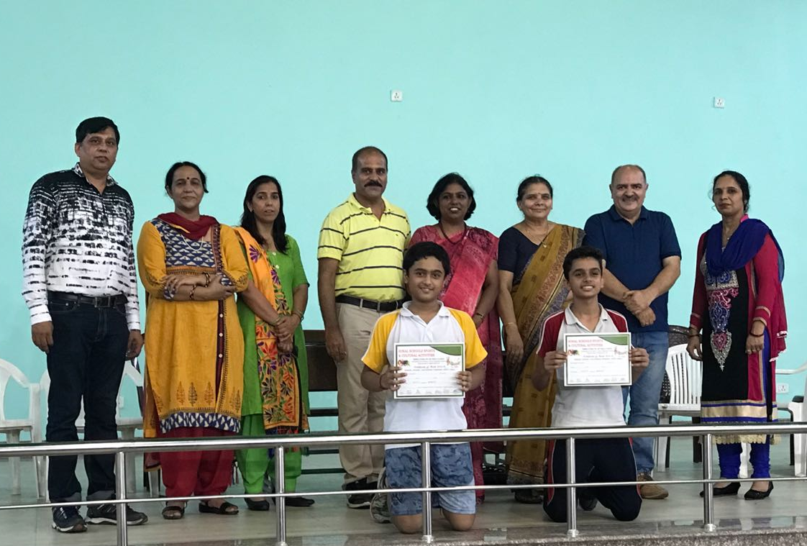

In swimming Surbhi Sharma got first place in 50m, 100m and 200 m free style event, 2nd place in100 IM.
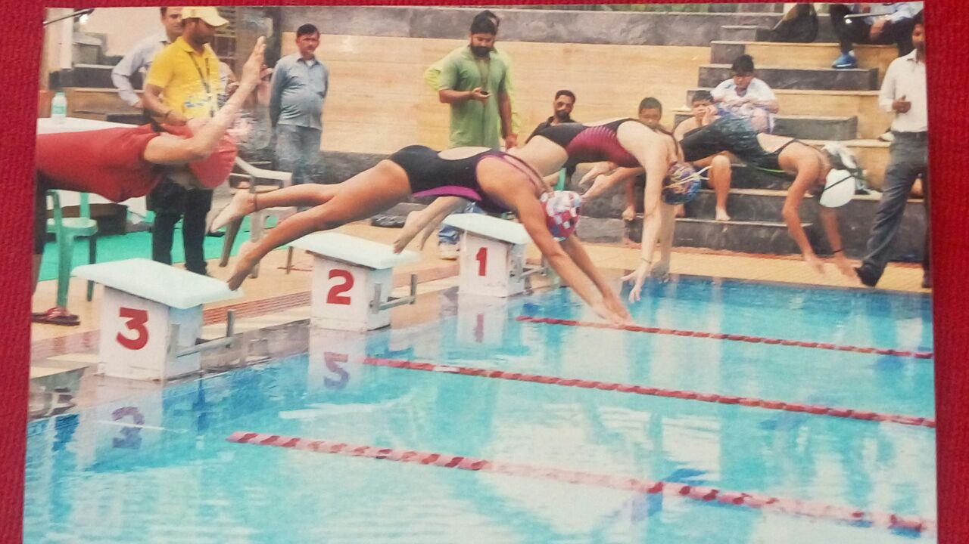

DAV Pushpanjali secured 3rd position in Zonal level Volleyball Tournament sub Jr Girls
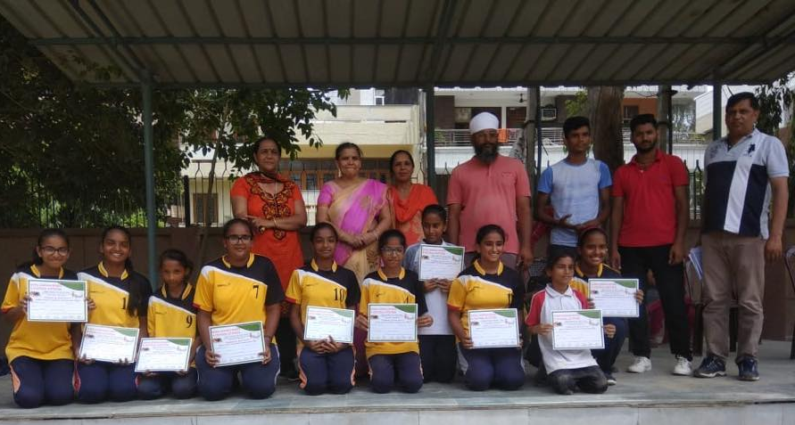

DAV Pushpanjali secured 1st position in Zonal Volleyball Tournament Sr Boys
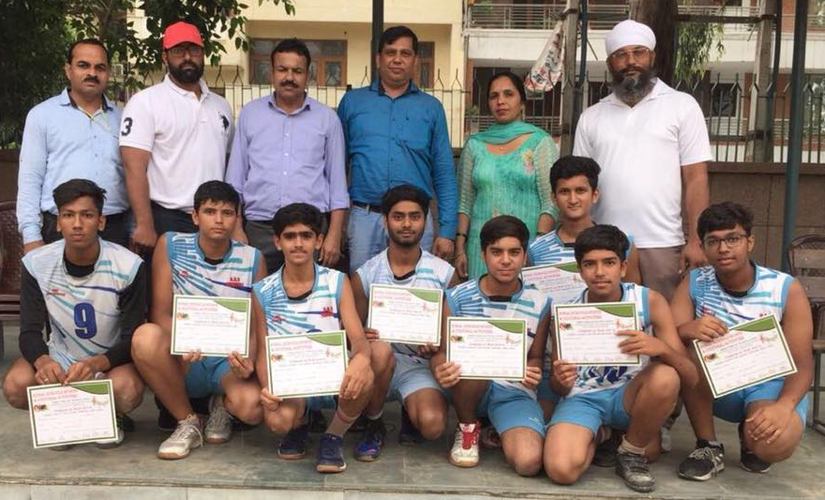

Asmit of class 8 got second place in Zonal Chess tournament

